Full Stack Development with MERN
SB Stocks – Virtual Stock Trading Platform
Project Documentation

1. Introduction
- Project Title: SB Stocks – Virtual Stock Trading Platform
- Team Members: [List team members and their roles — e.g. Frontend Developer, Backend Developer, Database/Deployment]
2. Project Overview
Purpose
SB Stocks is a full-stack MERN virtual stock trading platform that lets users learn and practice stock market trading using virtual (mock) money. It gives users a realistic trading loop — live prices, buy/sell execution, portfolio tracking and profit/loss calculation — without any real financial risk, alongside an admin dashboard for managing stocks and users.
Features
User Features:
- JWT authentication with secure registration and login
- Password encryption using bcrypt
- Virtual wallet, buy/sell stocks, portfolio management
- Profit & loss calculation, order history, transaction history
- Watchlist, live stock prices (Finnhub API), company search
- Candlestick charts, responsive dashboard, profile page
Admin Features:
- Admin authentication and dashboard statistics
- View/delete users; view all orders and transactions
- View, add, edit and delete stocks; update stock prices
3. Architecture
Frontend
Built with React and Vite, styled using Tailwind CSS. React Router DOM handles client-side routing across auth, dashboard, stock market, portfolio, watchlist and admin views. Axios performs API calls, React Hook Form manages form state/validation, React Toastify shows in-app notifications, ApexCharts renders candlestick/price charts, and Lucide React supplies icons.
Backend
Built with Node.js and Express.js. Routes are grouped by domain (auth, stocks, orders, portfolio, transactions, watchlist, admin) and delegate to controllers containing the business logic. Middlewares handle JWT verification and admin-only route protection. Morgan logs HTTP requests during development.
Database
MongoDB stores the application's data, accessed through Mongoose schemas/models covering Users, Stocks, Orders, Transactions, Portfolio holdings and Watchlist entries. MongoDB Compass is used for local development and MongoDB Atlas for demo/production.
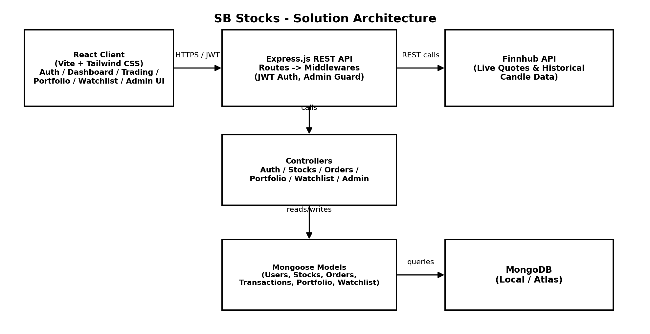
4. Setup Instructions
Prerequisites
- Node.js (LTS recommended) and npm
- MongoDB — local instance (MongoDB Compass) or a MongoDB Atlas connection string
- A Finnhub API key (free tier) for live stock data
Installation
1. Clone the repository:
git clone https://github.com/saiteja-vinnakota/Stock-Trading-App.git
cd SB-Stocks
2. Install and run the server:
cd server
npm install
npm run dev
3. Install and run the client:
cd client
npm install
npm run dev
4. Create a .env file inside the server folder:
PORT=5000
MONGO_URI=YOUR_MONGODB_URI
JWT_SECRET=YOUR_SECRET_KEY
FINNHUB_API_KEY=YOUR_FINNHUB_API_KEY
5. (Optional) Seed demo data — users, stocks, portfolios, orders, transactions and watchlists:
npm run seed
5. Folder Structure
Client
The React frontend (client/) contains src (components, pages, routing), public (static assets), package.json and vite.config.js.
Server
The Node.js backend (server/) is organized by responsibility: config (DB/API config), controllers (business logic per domain), middlewares (auth/admin guards), models (Mongoose schemas), routes (Express routers), seed (demo data scripts), utils (helpers), package.json and index.js (entry point).
SB-Stocks
├── client
│ ├── src
│ ├── public
│ ├── package.json
│ └── vite.config.js
│
├── server
│ ├── config
│ ├── controllers
│ ├── middlewares
│ ├── models
│ ├── routes
│ ├── seed
│ ├── utils
│ ├── package.json
│ └── index.js
│
├── .gitignore
├── README.md
└── LICENSE
6. Running the Application
- Backend: from the server directory, run npm run dev (starts the Express API, default port 5000).
- Frontend: from the client directory, run npm run dev (starts the Vite dev server).
Demo accounts (after seeding):
- Admin — admin@sbstocks.com / Password@123
- Users — saiteja@gmail.com, priya@gmail.com, rohan@gmail.com (all Password@123)
7. API Documentation
Authentication
Method | Endpoint | Description
POST | /api/auth/register | Register a new user
POST | /api/auth/login | Authenticate a user and issue a JWT
GET | /api/users/profile | Get the logged-in user's profile

Stocks
Method | Endpoint | Description
GET | /api/stocks | List all stocks
GET | /api/stocks/search | Search stocks by name/symbol
GET | /api/stocks/details/:id | Get details for a specific stock
GET | /api/stocks/history/:symbol | Get historical price data for a stock

Orders
Method | Endpoint | Description
POST | /api/orders/buy | Place a buy order
POST | /api/orders/sell | Place a sell order
GET | /api/orders | List the logged-in user's orders

Portfolio
Method | Endpoint | Description
GET | /api/portfolio | Get the logged-in user's portfolio
GET | /api/portfolio/:id | Get a specific portfolio entry

Transactions
Method | Endpoint | Description
GET | /api/transactions | List the logged-in user's completed transactions

Watchlist
Method | Endpoint | Description
GET | /api/watchlist | Get the logged-in user's watchlist
POST | /api/watchlist | Add a stock to the watchlist
DELETE | /api/watchlist/:id | Remove a stock from the watchlist

Admin
Method | Endpoint | Description
GET | /api/admin/dashboard | Get aggregated dashboard statistics
GET | /api/admin/users | List all users
GET | /api/admin/orders | List all orders (all users)
GET | /api/admin/transactions | List all transactions (all users)
GET | /api/admin/stocks | List all stocks (admin view)
POST | /api/admin/stocks | Add a new stock
PUT | /api/admin/stocks/:id | Edit an existing stock
DELETE | /api/admin/stocks/:id | Delete a stock

Note: request/response payload examples should be added per endpoint as the API is finalized (e.g. sample JSON bodies for register/login and buy/sell).
8. Authentication
- Registration and login are handled via /api/auth endpoints; passwords are hashed with bcrypt before storage.
- On successful login, the server issues a JWT which the client stores and sends as a Bearer token on subsequent requests.
- Protected routes use an auth middleware to verify the JWT; admin-only routes use an additional admin-authorization middleware.
9. User Interface
[Insert screenshots or GIFs of the Login/Register page, Dashboard, Stock Market/Search page, Stock detail with candlestick chart, Buy/Sell flow, Portfolio page, Order/Transaction history, Watchlist, and Admin Dashboard.]
10. Testing
Manual User Acceptance Testing was carried out against the core flows — registration/login, live price lookup, buy/sell order execution (including insufficient-balance and over-sell edge cases), watchlist management, and admin operations. See the separate User Acceptance Testing (UAT) document for the full test case and bug tracking log.
11. Screenshots or Demo
Live demo: https://stock-trading-app-beige.vercel.app
[Insert additional screenshots or a recorded demo link here.]
12. Known Issues
- Stock prices update on request rather than by push — there is no live WebSocket feed yet, so prices refresh on reload/interaction rather than continuously.
- [Add any other known bugs or limitations observed during testing.]
13. Future Enhancements
- Real-time price updates via WebSockets
- AI-based stock recommendations
- Stock news integration
- Deeper portfolio analytics and dividend tracking
- Support for multiple stock exchanges
- Dark mode and a dedicated mobile app
- Email notifications for order execution and account activity

